**K8S API Group**

API Doc Overview

<https://kubernetes.io/docs/reference/generated/kubernetes-api/v1.22/#endpoints-v1-core>

1. 查看API groups

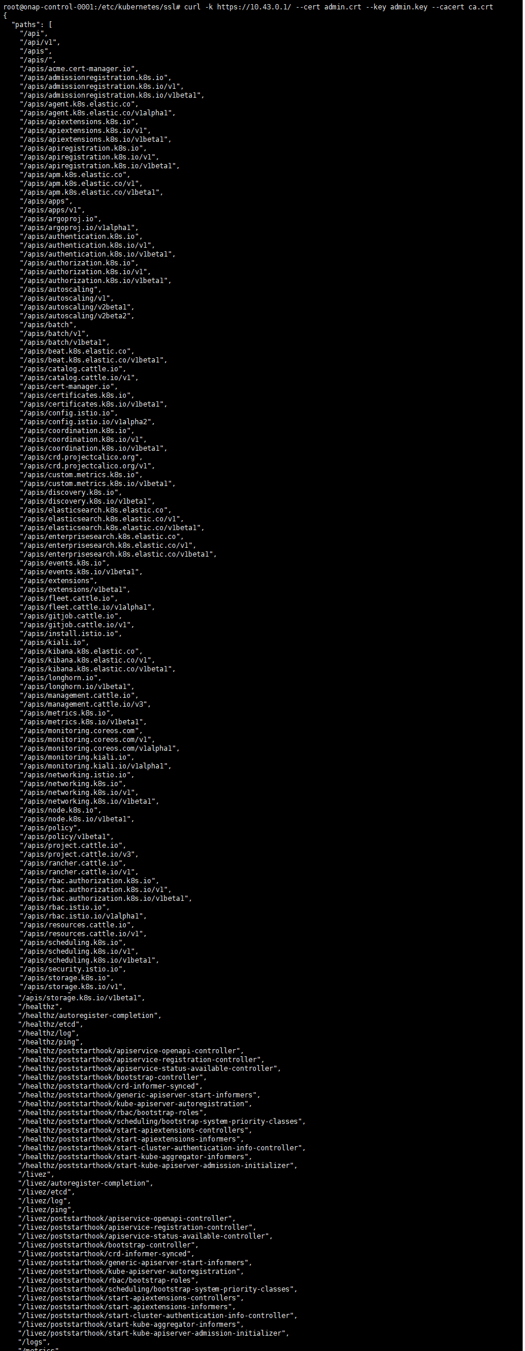

1. /metrics

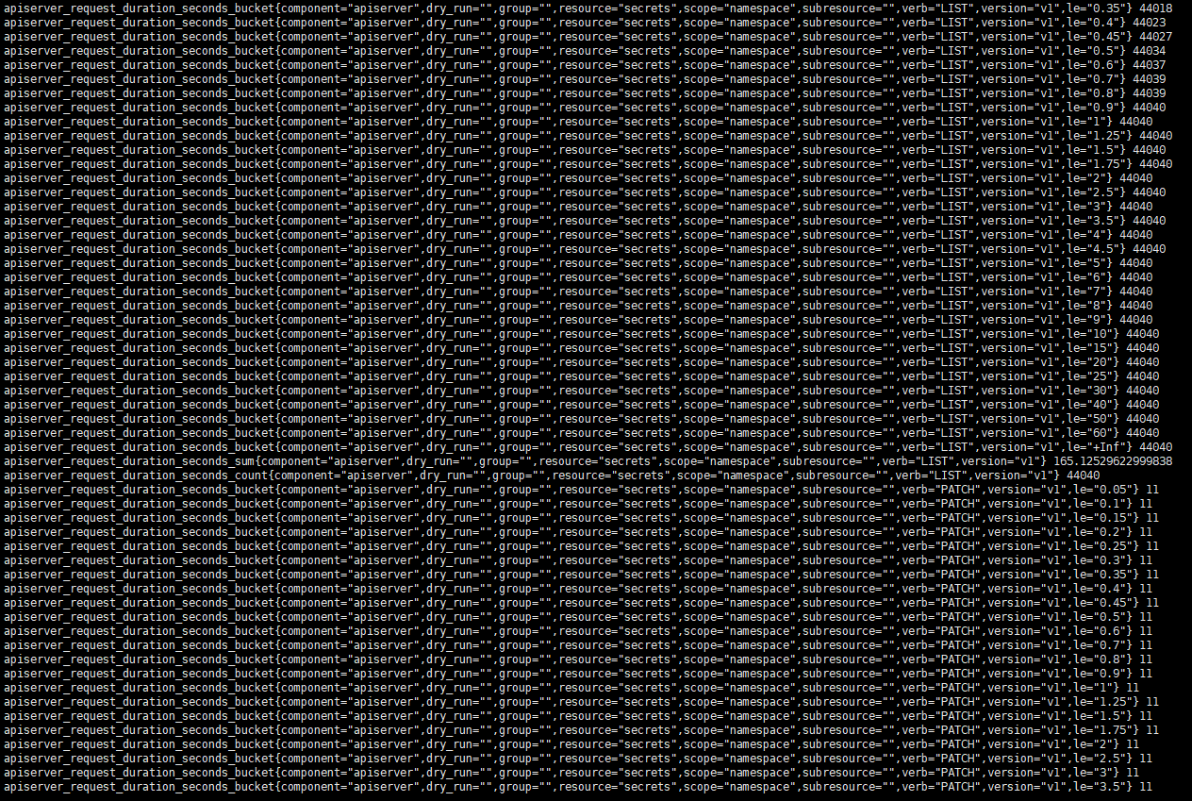

1. /healthz



1. /version

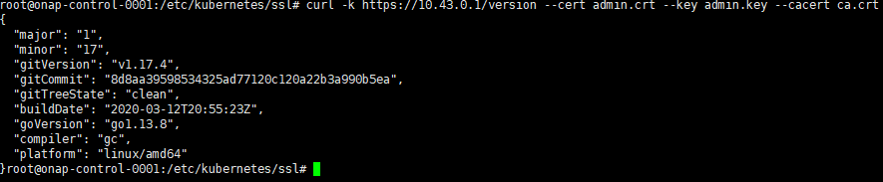

1. /api

Core group

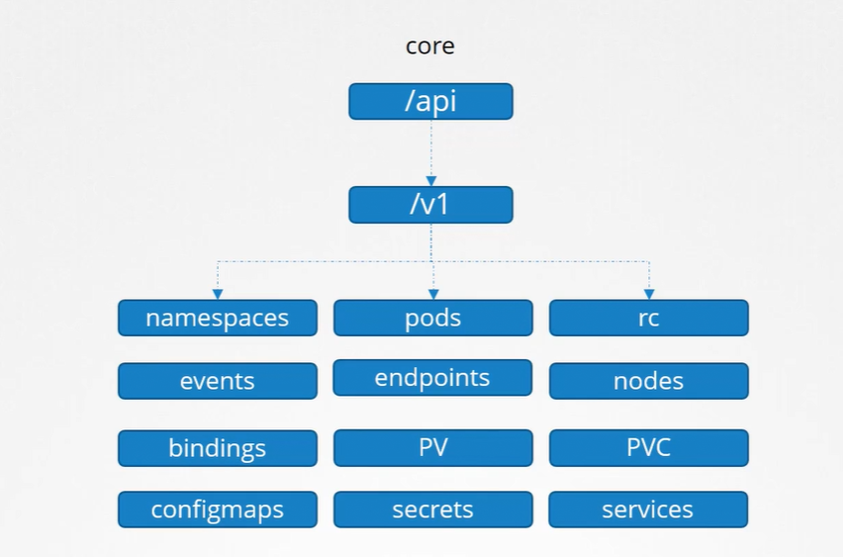

/api

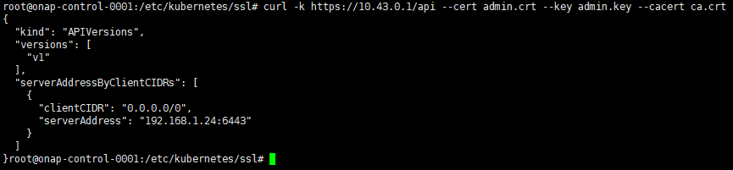

/api/v1

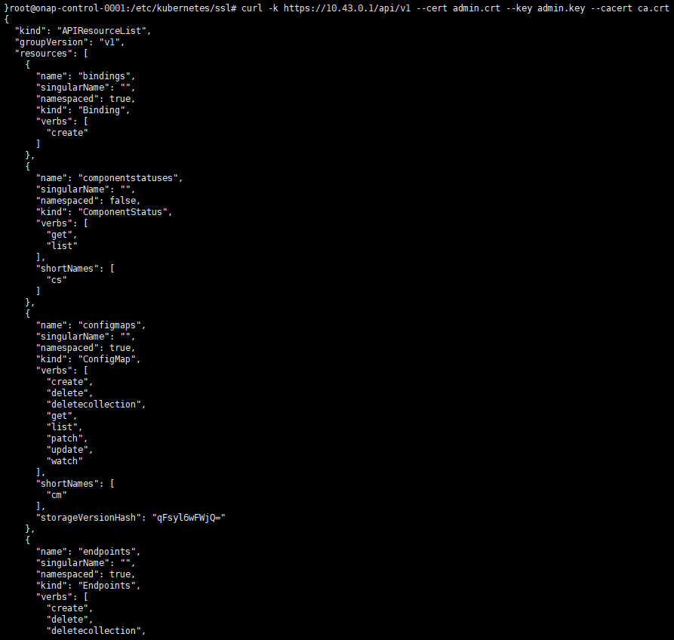

1. /apis

Named group, more organized

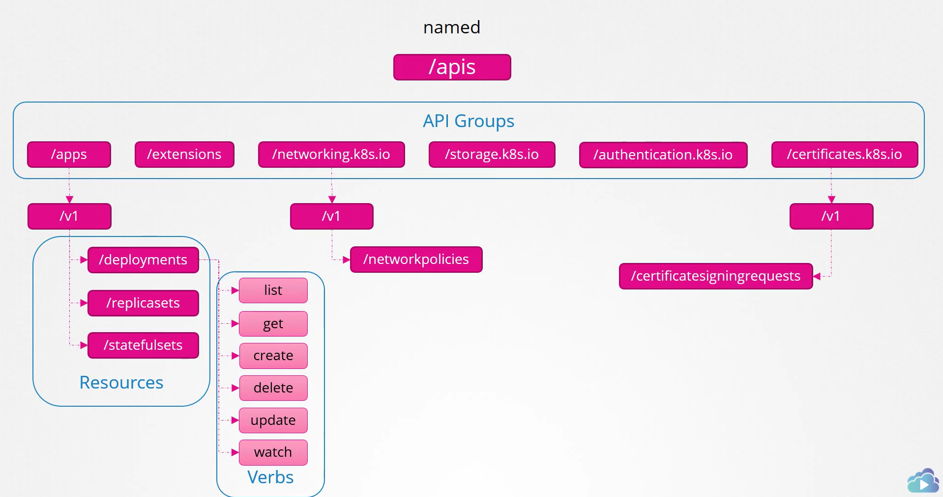

1. /logs